GLOBAL
SHEEP GENETICS
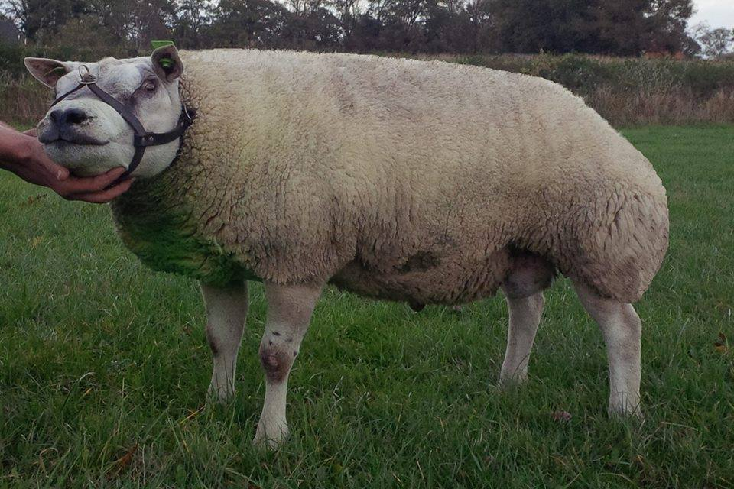

RAM CATALOQUE
2015-2016

Welcome to Global Sheep Genetics!
Global Sheep Genetics has been founded in Finland 2014. Global Sheep Genetics is the result of finnish-dutch cooperation between HH Embryo Ltd and van Aken Texels. The idea is to provide semen from best dutch texels worldwide. New AI Station was opened on November 2014 and is now ready to serve you in all your AI needs.

Global Sheep Genetics/
HH Embryo Ltd
Huitinraitti 33
12750 PILPALA
FINLAND
e-mail: info@huitinholstein.net
tel: +358-500-735827
Find us on facebook

Mikko Ranta
+358-40-581 9616
mikko.ranta@huitinholstein.net
Hannu Huitti
Hannu.huitti@huitinholstein.net
+358-40-8218315
Sanna Lehto
+358-500-735827
sanna.lehto@huitinholstein.net

Global Sheep Genetics in a nutshell:
- We produce high quality semen of the best texel rams
- We also have top quality finnsheep semen available
- Our semen is from best texels of the Netherlands and it is produced in EU- accredited AI Centre in Finland.
- All semen is EU- accredited
- We have doses available both laparoscopic (150M/straw) and shot in the dark inseminations
- In the future we´ll have also embryos available
- All our texels are scrapie resistant ARR/ARR
- All our rams are tested negative for Scrapie, Maedi visna, Blue tonque, Bruscella ovis, Bruscella melitenensis and Border disease
- Visit our web store at www.huitinholstein.net/tuotteet.html or send on e-mail to info@huitinholstein.net
- Prices are available in our web site or on request for larger orders.

Ten Pierik Rambo 02343
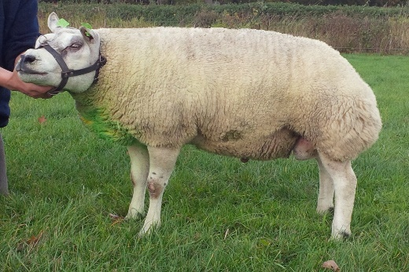
NL 01548-02343 25.02.2011 ARR/ARR (1)
MUSCLE: 90 LEGS: 85 OVERALL: 90
RAM: NL 04030-04107 (2) M:90 L:85 O:89
EWE: NL 01548-01676 (2) M:86 L:87 O:86

Van Aken Goldfinger 67389

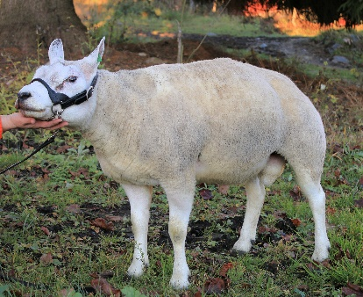
NL 01851-67389 21.03.2013 ARR/ARR (3)
MUSCLE: NA LEGS: NA OVERALL: NA
RAM: NL 01474-18733 (3) M:92 L:84 O:89
EWE: NL 01851-05802 (2) M:92 L:88 O:93

Van Aken Mozart
66971
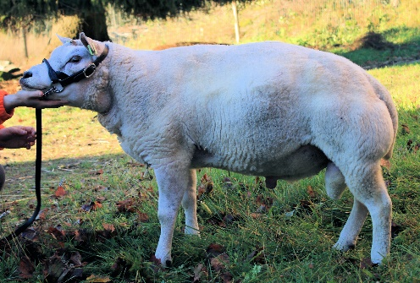
NL 01851-66971 01.03.2012 ARR/ARR (2)
MUSCLE: 90 LEGS: 88 OVERALL: 89
RAM: NL 01851-66310 (2) M:90 L:87 O:89
EWE: NL 01851-05751 (2) M:86 L:86 O:86

Van Aken Vivaldi
66959
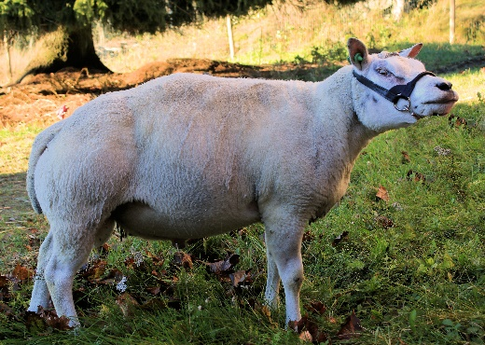
NL 01851-66959 01.03.2012 ARR/ARR (2)
MUSCLE: 90 LEGS: 86 OVERALL: 88
RAM: NL 01851-66330 (2) M:93 L:85 O:90
EWE: NL 01851-66322 (2) M:93 L:89 O:93

Van Aken Domingo 67009
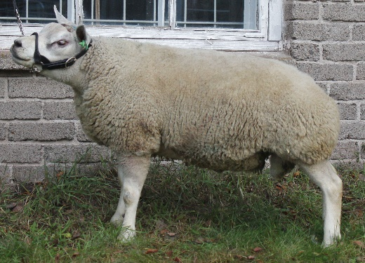
NL 01851-67009 06.03.2012 ARR/ARR (2)
MUSCLE: 89 LEGS: 87 OVERALL: 88
RAM: NL 01851-66319 (1) M:93 L:86 O:88
EWE: NL 01851-66401 (2) M:88 L:83 O:86

Van Aken Pavarotti
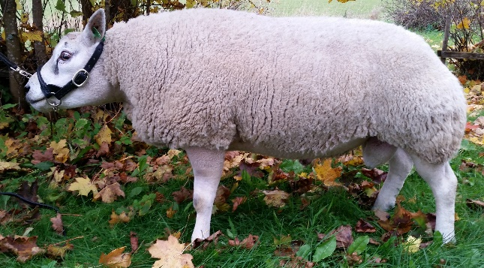
67010
NL 01851-67010 06.03.2012 ARR/ARR (2)
MUSCLE: 90 LEGS: 88 OVERALL: 89
RAM: NL 01851-66319 (1) M:93 L:86 O:88
EWE: NL 01851-66401 (2) M:88 L:83 O:86

Van Aken Colosseum 67356
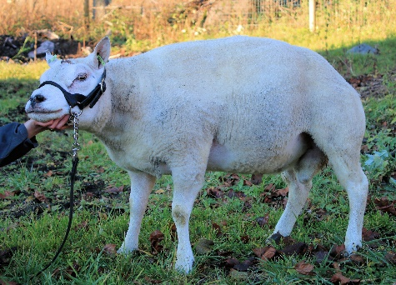
NL 01851-67356 18.03.2013 ARR/ARR (2)
MUSCLE: NA LEGS: NA OVERALL: NA
RAM: NL 01851-66676 (2) M:90 L:85 O:89
EWE: NL 01851-66909 (2) M:88 L86 O:88

Van Aken Beethoven
67375
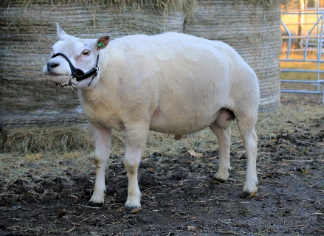
NL 01851-67375 19.03.2013 ARR/ARR (2)
MUSCLE: NA LEGS: NA OVERALL: NA
RAM: NL 01851-66825 (2) M:90 L:87 O:89
EWE: NL 01851-66844 (1) M:87 L:86 O:86

Van Aken Sokal
67427
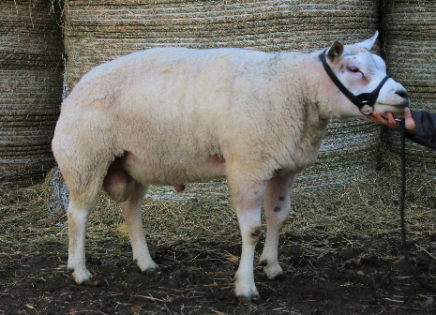
NL 01851-67427 03.04.2013 ARR/ARR (1)
MUSCLE: NA LEGS:NA OVERALL: NA
RAM: NL 04078-02377 (2) M:88 L:86 O:88
EWE: NL 01851-66975 (2) M:88 L:87 O:88

BLUE TEXEL RAMS
Nijboer Prince Charming
41885
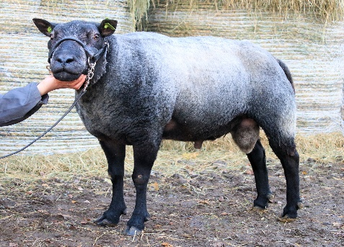
NL 08476-41885 04.03.2012 ARR/ARR (1)
MUSCLE: 88 LEGS: 85 OVERALL: 88
RAM: NL 08441-00609 (2) M:91 L:86 O:90
EWE: NL 05091-00954 (2) M:93 L:87 O:93

Oolman Humphrey Bogart 92635
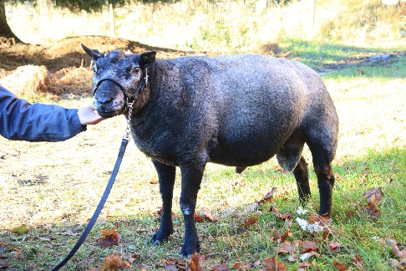
NL 26262-92635 13.03.2013 ARR/ARR (3)
MUSCLE: 88 LEGS: 84 OVERALL: 87
RAM: NL 08401-73883 (2) M:88 L:86 O:88
EWE: NL 26262-92561 (1) M:89 L:85 O:8

WHITE FINN RAMS
Rantamaan Reiska
166
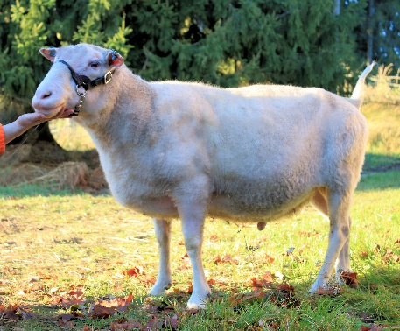
FI000001018046 6 .2010 SCRAPIE GENOTYPE NA (2) LAMBS 2,3/2,0
MUSCLE INDEX: 103/97 FAT INDEX: 107/97
SEUROP INDEX: 110/97 MEAT INDEX: 106/97
RAM: 3034 6 (3) M:100/1 F:106/1
(1,7/1,7) S:106/1 ME:116/1
EWE: FI000000510192 43 (3) M:100/1 F:104/1
(2,7/2,3) S:107/1 100/1
Ingon Ior
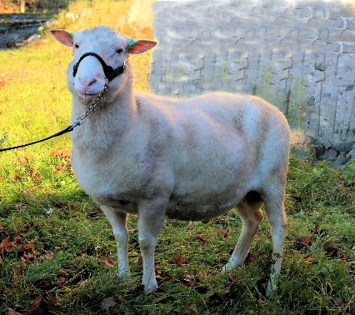
1607
FI000025463076 3 11.1.2014 SCRAPIE GENOTYPE NA
BORN (2) LAMBS 2,0/2,0
MUSCLE INDEX: 80 FAT INDEX: 116/
SEUROP INDEX: 96/1 MEAT INDEX: 115/1
RAM: FI000025122968 3 (2) M:55/56 F:135/56
(2,0/2,0) S:70/56 ME:96/56
EWE: FI000025153136 12 (3) M:106/6 F:98/6
(2,3/2,3) S:116/6 115/6

Dutch Texel breed: for high-quality lamb production
History
The Netherlands have a long history of sheep breeding. The Dutch sheep population is estimated at 1.5 million spread over about 20.000 farms. Some of the more specialized sheep farms keep over 300 ewes. Most sheep are kept on dairy farms as a side-line, with ewes lambing in the spring. The activities of sheep breeding, multiplication and slaughter lamb production are all integrated on the farms. In the Netherlands, sheep are kept mainly for meat production. The profitability of sheep production is determined by lamb production, growth rate and slaughter quality.
Over the last few decades Dutch sheep breeders have invested considerable amounts of money in research to improve the profitability of sheep farming. Through the use of rams with high genetic potential, much progress has been made in improving the functional conformation traits and carcass composition. In the past, the emphasis had been on economic mutton and wool production, but today the main aim is to sell slaughter lambs of constant, high quality.
Sheepbreeds Texel
Texel sheep evolved as a result of crossbreeding the Dutch polder sheep with several English breeds, such as the Leicester, the Wensleydale and the Lincoln at the beginning of 1900
Later, when cross-breeding no longer met the expectations, more influential breeders started breeding their own sheep. The result was a large fast-growing and rich-woolen animal. Today, as a result of efficient selection, the Texel breed has developed into a meat-type sheep of outstanding lean meat quality and has accordingly become increasingly popular amongst Dutch sheep farmers. The Texel ram is used for pure Texel breeding purposes and as sire in the production of slaughter lams in various cross-breeding programs in the Netherlands.

Discription of race
* the world’s most meaty mutton breed;
* rapid growth;
* excellent lean/bone ratio;
* does turn food to lean meat and not to fat;
* excellent mothering qualities;
* produces predominately twin lambs.
A grown ram has a weight of approximately 100 kg and a withersheight of approximately 72 centimeter. A grown ewe has a weight of approximately 75 kilo and a withersheight of approximately 68 centimeter. The Ducth Texel gives birth ones a year. Grown ewes produce predominately twin lambs.
It is possible for a Texel ewe to get her first litter at an age of 12 months.
The Dutch Texel has an excellent carcass composition. Due to their extremely low fat covering, lambs of the Texel breed can be sold over a long period of time with different end-weights, without any loss of carcass quality. Because of the breed’s extremely high degree of meatiness, the carcass has a killing-out percentage of 55 - 60%. The body of a Dutch Texel is well proportioned with extra strong loins, a solid square stance and round very well developed gigots.
Breeding goal
The main objective of the Texel flock books is to improve the quality of the purebred Texel sheep as much as possible. To achieve this goal the following requirements have to be met:
* two weaned lambs per litter;
* rapid growth of young lambs;
* maintaining good maternal characteristics;
* further improvement of the carcass qualities.
Over the past few years, breeders of the Dutch Texel sheep have, in addition to further improving the breed’s meatiness, worked intensively on its growth, fertility and functionality. These efforts have resulted in larger, longer animals that can easily carry and raise two lambs.
Features
Littersize
The Texel sheep are early maturing. The ewe lambs come already in heat at an age of about 7 months. The breeding season of the mature Texel is nearly 5 months. The average litter size of the mature Texel ewe is about 1.95 lambs at birth.
Good growth
Due to the ewes’ good milk production and the lambs’ excellent growth potential, an average growth of 300 grams per day is attained during the suckling period. During the grazing period of the lambs the growth is about 250 grams per day. If slaughtered at the age of 20 weeks, the lambs’ average live weight is 42 kg (about 22-23 kg. dead weight). This weight can be reached only on grass!
Maternal characteristics
The Dutch Texel ewe is a good mother. The milk yield of a Texel ewe is large enough for raising 2 lambs. The Texel sheep are excellent graziers and therefore easy to manage. This is also due to the good resistance to internal parasites.
Excellent carcass quality
The Texel breed is known for its excellent carcass composition. The carcasses on average consist of 60 percent lean meat. Due to their extremely low fat covering, lambs of the Texel breed can be sold over a long period of time with different end-weights, without any loss of carcass quality. Because of the breed’s extremely high degree of meatiness, the carcass has a killing-out percentage of 55 - 60%.
Texel-Beltex
Some people think there is a difference between a Texel and a Beltex. There is no difference, it’s the same breed! Beltex are Dutch Texels born in Belgium, possible out of two imported parents from Holland. Beltex is just a commercial name for a Dutch Texel born in Belgium.

